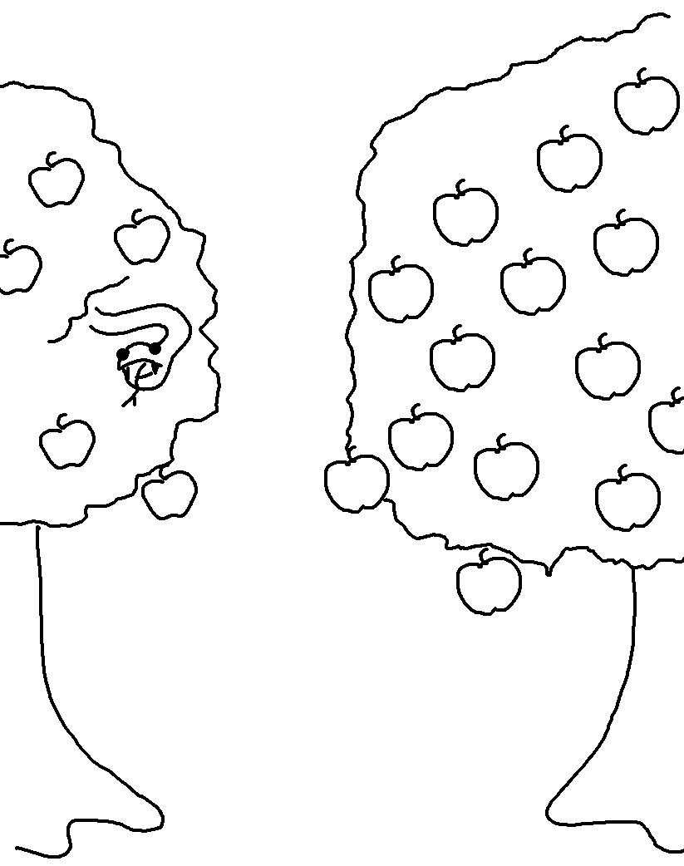
For the wages of sin is _ _ _ _ _, but the free _ _ _ _ of God is eternal _ _ _ _ through Christ Jesus our Lord. Romans 6:23_{NLT}

